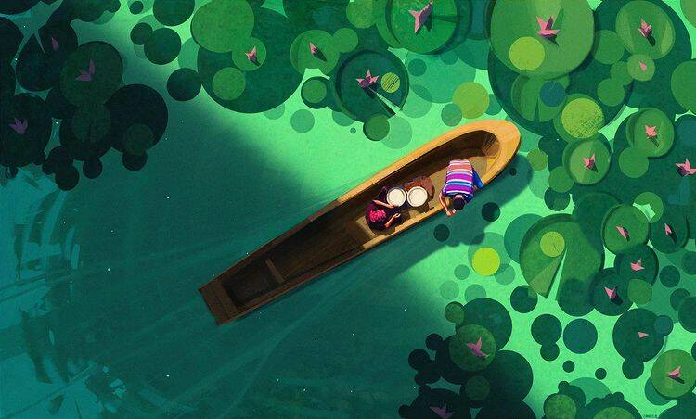

**Boat Across a Green Sea**

*Jocelin Carmes, 10/02/2022*

An artwork with ethereal calmness, it really reminds me of the feeling of slowing down, and how used to I am of being stuck in a hustle. Seafoam green is my favourite colour, and it covers the majority of the canvas here, and I love how the lilypads gather in front of them, but have spread out behind them, creating a feeling of motion through the sea. It’s a very wonderful piece of art, and I appreciate Sitesh for letting me in on digital artwork, something he’s passionate about, for good reason.

**Rule of Thirds**



original artwork edited to comply with rule

The artwork does follow the rule of thirds, when you consider the focal points of the beginning and end of the boat and the man’s torso falling directly on the lines.

Moving the painting to a more traditional rule of thirds ruins the framing, since the boat being in the centre creates the idea of a larger sea, which is lost when the **symmetry** is removed.

**Golden Ratio**

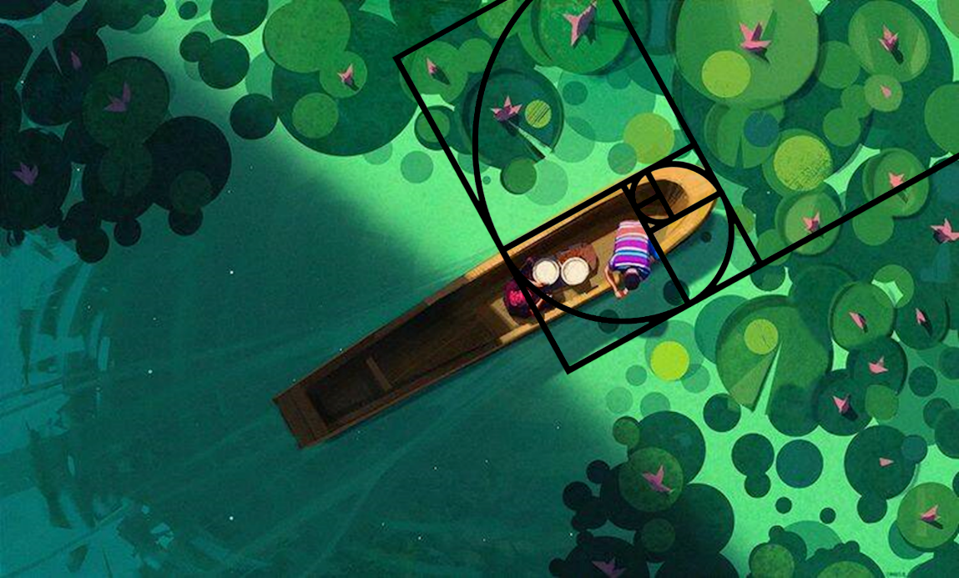

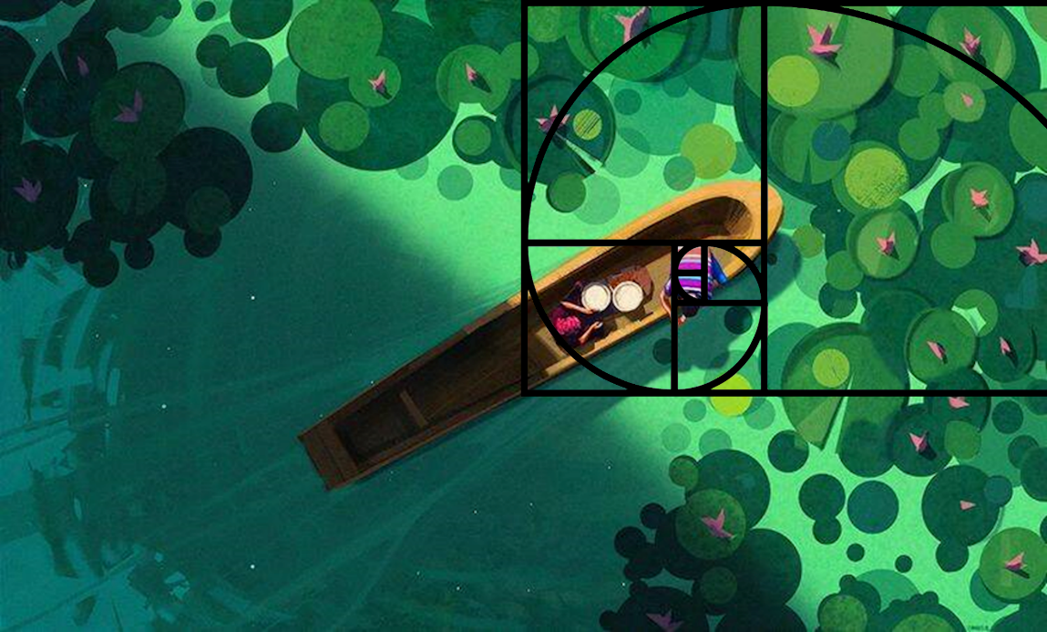

original artwork edited to comply with rule

The artwork follows the Fibonacci sequence in the placement of the people, in both the distance of the woman with the man, and the distance of both from the edge of the boat.

**Detail and Colour**

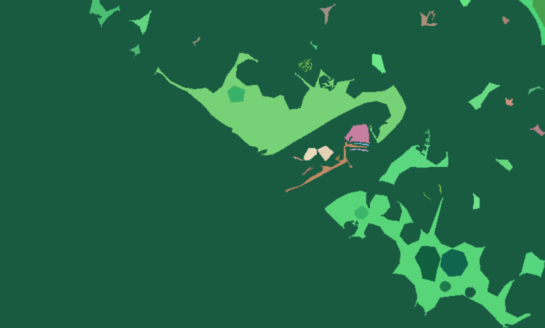

The artwork is sparsely detailed, instead opting for a more minimal approach. Hence, the little details stand out, eg, the people being barely 5% of the canvas size are more detailed than the rest of the piece, which is rather simplistic. The man’s shirt is deliberately multicoloured and striped, evidencing this feature.

The shadow in the left side of the artwork divide the painting into two parts, further exaggerating the symmetry, and creating a darker version of the top-right on the bottom-left, as the boat folds into itself.